
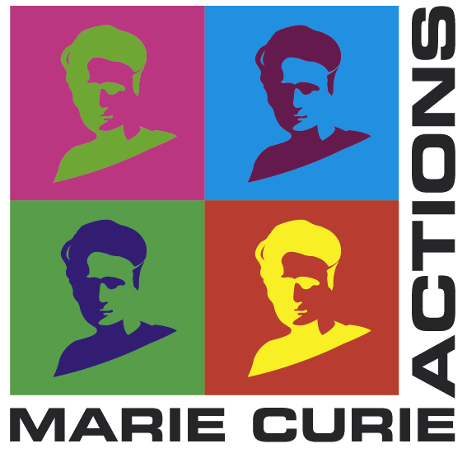






Innovation in Vision Research
Postdoctoral Training Network

Application Form

The deadline for completed applications is:
October 5, 2026 at 4:00pm Irish Time.
Applications submitted after this time will result in applications being deemed ineligible.
The INNOVISION Hiring Committee will only accept full and completed applications submitted through the online portal as described in the Application Guidelines. Please do not send hard copies or emails of applications to anyone in the INNOVISION Programme. Applications not submitted through the online portal will be deemed ineligible.
Please read the Terms and Conditions on the INNOVISION website, as well as this document, thoroughly, prior to submission.

Application Form – to be uploaded into the Microsoft Form as PDF
Instructions:
Please complete the following proposal within page limits specified. You may delete instructions prior to submission to reduce space. Font size must be at least font size 11, Calibri, or equivalent. Margins must be at least 2.5cm. Page limits must be adhered to. Any additional pages or unrequested documents will not be considered. Section 2 (Fellowship Proposal Introduction) may be 2 pages, Section 3 (Full proposal) should not exceed 10 pages, including all graphics, tables, and figures. A 1-page GANTT chart and a maximum of 2 pages of references may be added to this main document, at the end of the full proposal. Please save this as one complete PDF – (2 page introduction section, 10 page proposal, 1 page GANTT Chart, 2 pages references). Applicants may also submit an additional 1-page personal statement as a separate document within the portal, which should only include information not already emphasized within the proposal. Delete instructions as needed to save space.
Section 2: Fellowship Proposal Introduction
Project Title:
Primary Area, and Discipline: Please refer to the Document “Research Categorisation” on the INNOVISION Supporting Documents
Optional: Secondary Area and Discipline: Please refer to the Document “Research Categorisation” on the INNOVISION Supporting Documents
Five Key Words:
Recruiting Organisation and Proposed Main Supervisor:
Optional: Recruiting Organisation Co-Supervisors:
Optional: Secondment Organisation and Secondment Supervisor:
Scientific Abstract (Max 500 words): Write a clear abstract summarising your project and alignment to INNOVISION aims. State the research question or objective, outline the methods/approach, highlight key expected outcomes, and note the potential significance or impact. Avoid jargon and ensure it can be understood by a broad scientific audience.
Lay Abstract (Max 300 words): Write a plain-language abstract that explains your project to a non-specialist audience. Describe what you are researching, why it matters, and how it could benefit people or society. Avoid technical terms, acronyms, and complex language.

Section 3: Fellowship Main Proposal
Excellence: Please provide details of your proposed research to include aims, objectives and central research questions of the project in terms of ocular health research. Explain how the proposal relates to the “state of the art”. Suggest how the project will make a new contribution to knowledge. Use footnotes for references. Demonstrate how your proposed fellowship fulfills the aims of the scheme as outlined in the Guide for Applicants. Outline how the academic and other non-academic spheres will benefit from the proposed research (such as translation of research findings into policies and practice, integrating research and innovative approaches into programming and activities, conducting impact assessment, creating/strengthening collaborations with research performing organisations etc.) Include details on how you will incorporate Public and Patient Involvement (PPI) in your research plan. The PPI Ignite Network in Ireland offers excellent resources on how to incorporate PPI. Please describe the research design and methodologies to be employed in carrying out your fellowship, to include for example investigative and analytic methods and theoretical frameworks, (including interdisciplinary approaches, consideration of the gender dimension and other diversity aspects if relevant for the research project, and the quality of open science practices, including sharing and management of research outputs and engagement of citizens, civil society, and end users, where appropriate).
Impact Part 1 - Career Development: Your proposed career training and development plan should present your mid-term goals and long-term career objectives and how the fellowship will help you to achieve these goals. Outline how your fellowship will fulfill the relevant aims of the scheme, as specified in the Guide for Applicants. Provide a description of planned training activities for the acquisition of new knowledge and skills. For example, gaining research skills and techniques, communication skills, research management, networking, and other transferable skills etc. during the period of the fellowship, and during any secondments. Outline the expected transfer of knowledge between you, your recruiting organization, and the seconding organization(s) if applicable. Give a rationale for, and indicate the added value of the type of secondment (international, intersectoral, and/or international) if applicable. Detail how the fellowship will enable you to gain skills relevant to employment outside the traditional academic sector. Detail how the fellowship will enable you to acquire competencies that improve the prospects of reaching and/or reinforcing a position of professional maturity, diversity and independence. In addition to outlining your individual training plans, and their benefits, detail how your research and career development will benefit from the INNOVISION programme-wide training. The Vitae website and Researcher Development Framework is an excellent career development resource that you may find useful when preparing your Career Training and Development Plan.
Impact Part 2 – Dissemination and Communication: Please outline your plans for dissemination and knowledge exchange of your research, including publications, conference attendance, poster presentations and reports. Describe the dissemination, exploitation measures that are planned, and the target group(s) addressed (e.g., scientific community, end users, policy makers, public at large). Regarding communication measures and public engagement strategies, outline how you will reach out to society and show the benefits of the research you are conducting and associated outputs. Indicate how impact of your fellowship will be measured. Applicants should adhere to the Horizon Europe “Communicating EU research and innovation guidance for project participants” document. Estimated length of this section is 500 - 700 words.
Impact Part 3 –Contribution to Broader Impacts: Please describe your project’s contribution to the expected scientific, societal, and economic impacts in respect of the global vision health crises. Provide a narrative explaining how the project’s results are expected to make a difference in terms of impact, beyond the immediate scope and duration of the project, referring to the effects of your project, and not R&I in general in this field. State the target groups that would benefit.
Implementation Part 1 – Schedule, Deliverables, and Milestonse: Please provide a schedule to include (a) milestones and deliverables for completion of the proposed fellowship, (b) risks that might endanger reaching these deliverables and (c) the contingency plans to be put in place in order to mitigate these risks. Please reference a Gantt chart representing their fellowships’ schedule, to include secondment(s), milestones and deliverables, outreach and dissemination activities etc., as outlined in the fellowship proposal, including the career training and development plan. This GANTT chart may be added at the end of the document, before the references, as an additional page.
Implementation Part 2 – Project Management: Please describe the organisation and management structures in place to ensure objectives are met. Discuss the research and/or administrative risks that might endanger reaching your objectives and the contingency plans to be put in place should risks occur. Please outline the reasons for choosing the proposed main host organization and secondment organization(s) if applicable. Describe the relevant research infrastructure, logistics, facilities, training and development opportunities and relevant resources that will be available to you in the proposed home host organisation. Detail the nature and quality of the research group as applicable, and how you will be integrated in order that maximum knowledge and skills can be gained from the fellowship.
Implementation Part 3 – Supervisor Selection: Please outline the reasons for choosing your proposed main supervisor, co-supervisor(s), and secondment supervisor (if applicable). Include information about the proposed main supervisor’s relevant key research achievements, involvement in research and training programmes, collaborations with relevant non-academic organisations, mentoring etc. Include information about the proposed supervisor’s relevant key achievements, involvement in research and training programmes, collaborations with higher education institutions/research performing organisations, mentoring etc.

